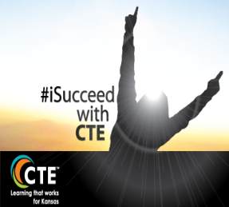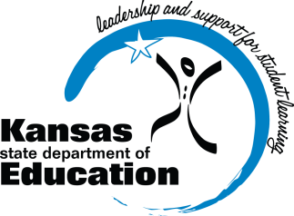
KSDE CTE Update

Counselors Council

2.12.15

- Professional Development
  - KSDE is attempting to consolidate our professional development events by focusing as an agency on summer Impact Institutes (July 2015) and the Annual KSDE Conference (October 2015).

- Individual Plans of Study
  - Identifying best practices in both the product and the process involved in individual plans of study for all secondary students.
  - Crucial piece for all schools to help students be more college and career ready
  - Individual Plans of Study Webpage

- State Funding for CTE
  - It’s been proposed by the Governor to cut the Credential Incentive money (1.5 M) for this school year.
  - Proposed block grants to fund K-12 for the next two school years (eliminating all weightings)
  - The tuition money for high school students in Senate Bill 155 is still in the budget for this year and the next two school years (15-16 and 16-17).

- Developing Quality Pathway Goals
  - At least one goal must be submitted for each of the four Quality Pathway components: Physical environment, Partnerships, Instructional Strategies, Professional Development
  - Best Practice – Using the Quality Pathway Rubric as a needs assessment, have the Advisory Committee rate the current pathway and then develop 3-year goals for each component
  - Defining question: Does the goal drive improvement in that component over a 3 year period of time?
  - If a goal is disapproved, the consultants will provide feedback using SMART goal criteria

- Competency Profiles
  - Competency profiles (Perkins requirement) must be kept for each concentrator to document technical skills earned OR an end-of-pathway assessment is to be taken, both resulting in a level of comprehension/skill attainment indicating achievement.
End of pathway assessments may be used in lieu of the competency profile. To know if you have an end of pathway assessment, note Section 4 of the CPPSA. Only pathways with end of pathway assessment options will appear as choices to select in Section 4 of the pathway application. If an end of pathway assessment is offered, but not taken, the competency profile is your default option. These do not have to be hard copy as we have several schools that have created online versions to use. Once taken, they can also be scanned and saved electronically. Also note, only the students who are concentrators need their competency profile rubrics retained for a period of 5 years.

- Proposed New CTE Student Categories:
  - Participant – 0.5 CTE credit
  - Concentrator – 2.0 CTE credits (must be a combination of at least 2 of the 3 course levels)
  - Completer – 3.0 CTE credits (2.0 of the 3.0 credits must be a combination of technical/application level)
  - CTE Scholar
    - Completer
    - Academic - Passing score on a state-approved CCR assessment
    - Technical - Passing state-approved Technical Skill Assessment (TSA) or Industry-Recognized Certification (IRC)
Examples - cPass end-of-pathway assessments, verified IRC’s (recognized by industry at the state or national level, occupational-specific), CTSO state level competitive event achievement
    - Employable – successful completion of a professional learning experience, WorkKeys (silver level?), CTSO competitions, non-CTE related work experience, experiential learning
    - Leadership – CTSO officer at local, district, state, or national level, CTSO leadership awards, Student Council officer, Sports Team Captain, etc.
    - Community Service – (no. of minimum hours to meet this requirement)

- What’s New
  - Energy Pathway available for SY 15-16
  - District-level Pathway application ready for spring 2015 submission
  - Career Pathways Coordinator (KBOR/KSDE joint position)

KansasCTE@KSDE_CTE

